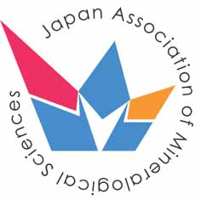Journal of Mineralogical and Petrological Sciences
Japan Association of Mineralogical Sciences
c/o Graduate School of Science, Tohoku University,
Aoba Sendai, 980-8578, Japan
E-mail: jmps_editorial@spa.nifty.com

The following transfer agreement must be signed and returned to the editorial office before the
manuscript is published.

COPYRIGHT STATUS FORM

TRANSFER OF COPYRIGHT AGREEMENT
I/We hereby agree to transfer to Japan Association of Mineralogical Sciences the copyright on all material of my/our paper, as specified below.
If there are multiple authors, only one signature is required
Title:

Author(s):

Author Signature:

Date:

